***FREE!* Chronic Pain  
Telephone Workshops**

**Choose a morning or evening program!**

Sponsored by the Western Connecticut Area Agency on Aging

and the Connecticut Department of Aging and Disability Services ~ State Unit on Aging.

Generous support is also provided by the Connecticut Community Foundation.



**You will learn:**

1. Techniques to deal with frustration, fatigue, isolation & poor sleep
2. Gentle exercises to help with pain
3. Ways to improve your nutrition
4. Appropriate use of medications
5. Other helpful information for managing your pain day-to-day

Materials will be sent directly to participants at no cost and include *Living a Healthy Life with Chronic Pain*, a booklet of tips, and a relaxation CD.

You’ll have a one-hour group phone call once a week for six weeks.

Class size is limited to six participants, **so register early**!

***Join a FREE 6-week workshop and learn how to better manage your ongoing health condition!***

Participants only need a phone, no other technology! Once a week, you just call our toll-free number to connect to the group call.

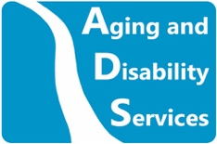

**Tuesdays, June 11—July 16 from 10–11am**

**OR  
Tuesdays, June 11—July 16 from 6-7pm**

**To register, call 203-757-5449 x 125 or**

**email Debby at dhorowitz@wcaaa.org**