ELMWOOD HALL
10 Elmwood Place Danbury, CT 06810

Announces a Special Presentation by:

Arthur N. Gottlieb, LCSW, CSA

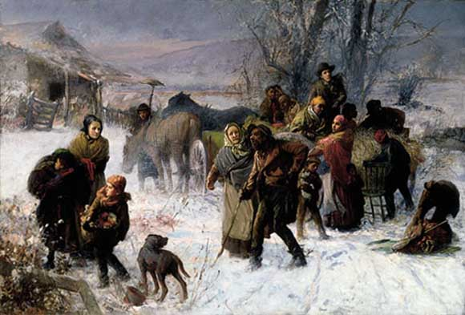

UNDERGROUND RAILROAD

Starting in the early 19th Century, abolitionists aided up to 100,000 Black slaves escape to Free states, Mexico and Canada through the creation of a vast secret network of routes and safe houses that came to be known as the Underground Railroad

Friday, April 21, 2017
10:30 am to 11:30 am

