**Legal Documents Seniors Need to Understand**

***Topic of Masonicare’s Lunch & Learn***

Attorney Barbara W. Reynolds will present an educational Lunch & Learn the legal documents necessary to ensure a comprehensive plan for the future. In her presentation, she will discuss:

*Wills versus Living Trusts*

*Long-Term Care and Estate Planning*

*Probate issues, Power of Attorney and Asset protection*

*Date:* **June 17, 2015**

*Time:*  **6:00 p.m.**

*Location:* **Masonicare at Newtown**

**139 Toddy Hill Road**

**Newtown, CT**

*This program is free and will begin with a complimentary light supper.*

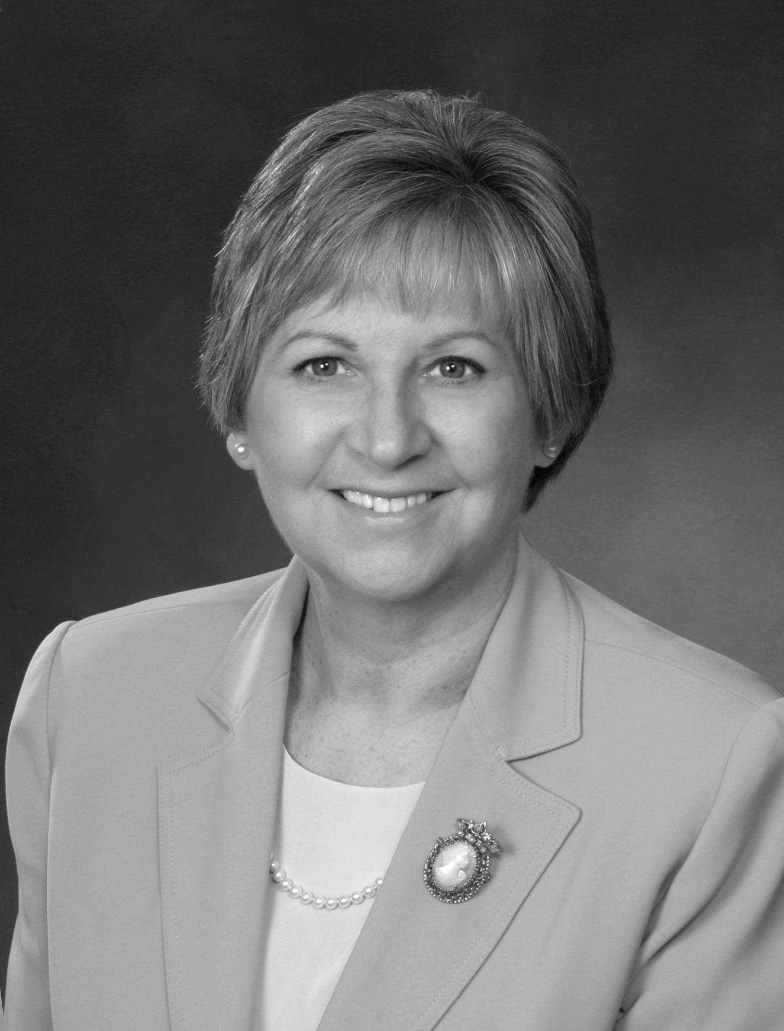

*RSVP required by June 12.*

**Please call the**

**Masonicare HelpLine.**

**888-679-9997**

