AARP DRIVE SMART CLASSES
FOR 2017 AT ELMWOOD HALL

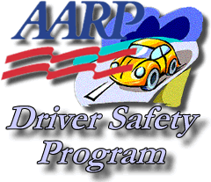

All classes are held
Wednesdays
From 8:45 a.m. to 1 p.m.

March 1
April 5
May 3
June 7
September 6
October 4
November 1

Cost is $15 for AARP members and $20 for non-members.
May be eligible for a discount on your insurance.

Call to sign up, 203-797-4686.
Make checks payable to: AARP Safe Driver Course
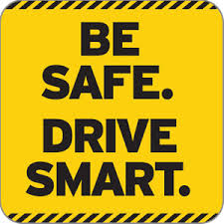
Pay up to 2 weeks prior to the course you want to take.

